目录
一、明细 3
二、佐证 5
1、The Research on Die Structure of Aluminum Alloy Bars for Preventing the Coarse Grain 5
2、A Integral Type Extrusion Die For Semi-Hollow Aluminum Alloy Profile 6
3、A Cover Type Hollow Extrusion Die for The Semi-hollow Al-profiles 7
4、The Aluminum Extrusion Die With Twin Cavities For The Frame In Solar Plate 8
5、A Cutting Type Porthole Die Structure For Semi-hollow Al-Profiles 9
6、A Protection Type Porthole Die With Twin Cavities For semi-Hollow Al-Profiles 10
7、A Covering Type Extrusion Die With Twin Cavities For Semi-Hollow Al-Profiles 11
8、A aluminum alloy extrusion die structure on the large flat tube 12
9、Study on Die Structure for Reducing Extrusion Force of Porthole Die 13
10、 An Extrusion die for parallel collection Al flat tube of automobile heat exchanger 14

一、明细
序号 | 论文、专著名称 | 年份 | 学术期刊或出版社名称 | 卷（期） | 作（著）者及名次 | 备注
1 | The Research on Die Structure of Aluminum Alloy Bars for Preventing the Coarse Grain | 2016.6 | Advances In Engineering Research | 第39卷 | 邓汝荣,郧鹏，黄雪梅 | ISTP收录
2 | A Integral Type Extrusion Die For Semi-Hollow Aluminum Alloy Profile | 2016.6 | Advances In Engineering Research | 第41卷 | 邓汝荣,黄雪梅 | ISTP收录
3 | A Cover Type Hollow Extrusion Die for The Semi-hollow Al-profiles | 2016.12 | Advances In Engineering Research | 第54卷 | 黄雪梅, 邓汝荣 | ISTP收录
4 | The Aluminum Extrusion Die With Twin Cavities For The Frame In Solar Plate | 2017.2 | International Conference on Material, Energy and Environment Engineering |  | 郧鹏,邓汝荣 | ISTP收录
5 | A Cutting Type Porthole Die Structure For Semi-hollow Al-Profiles | 2017.2 | Advances In Engineering Research | 第99卷 | 郧鹏,邓汝荣 | ISTP收录
6 | A Protection Type Porthole Die With Twin Cavities For semi-Hollow Al-Profiles | 2017.2 | Advances In Engineering Research | 第99卷 | 黄雪梅,邓汝荣 | ISTP收录
7 | A Covering Type Extrusion Die With Twin Cavities For Semi-Hollow Al-Profiles | 2018.5 | Earth and Environmental Science | 第128期 | 邓汝荣，黄雪梅 | EI收录
8 | A aluminum alloy extrusion die structure on the large flat tube | 2018.12 | Material Science and Engineering | 第439期 | 邓汝荣，黄雪梅 | EI收录
9 | Study on Die Structure for Reducing Extrusion Force of Porthole Die | 2019.5 | Applied Materials and Manufacturing Technology | 第621期 | 邓汝荣，黄雪梅 | EI收录
10 | An Extrusion die for parallel collection Al flat tube of automobile heat exchanger | 2019.9 | Material Science and Engineering | 第467期 | 邓汝荣，黄雪梅 | EI收录

二、佐证

1、The Research on Die Structure of Aluminum Alloy Bars for Preventing the Coarse Grain
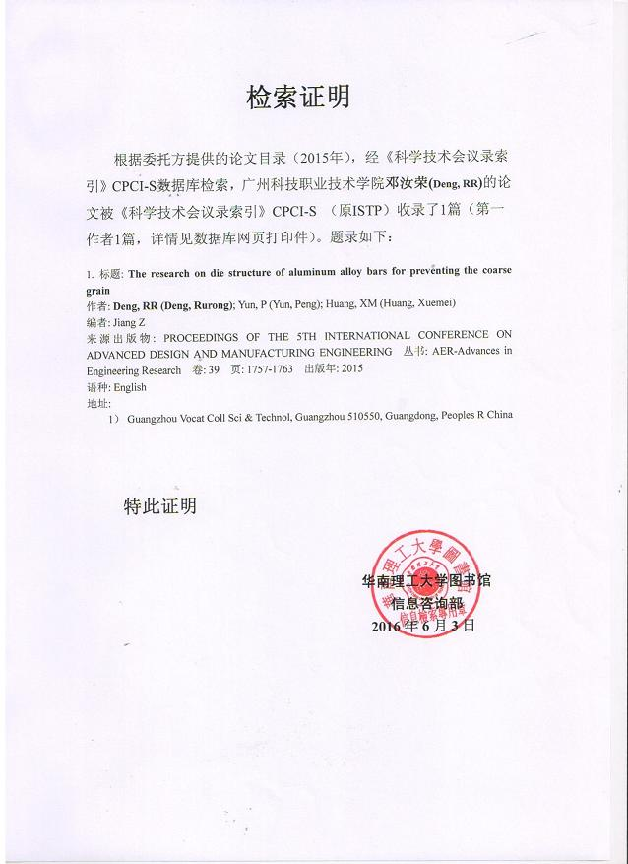

2、A Integral Type Extrusion Die For Semi-Hollow Aluminum Alloy Profile
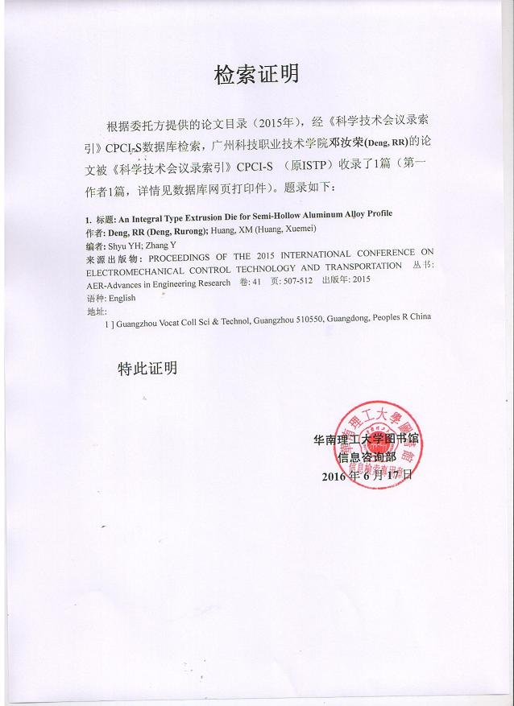

3、A Cover Type Hollow Extrusion Die for The Semi-hollow Al-profiles
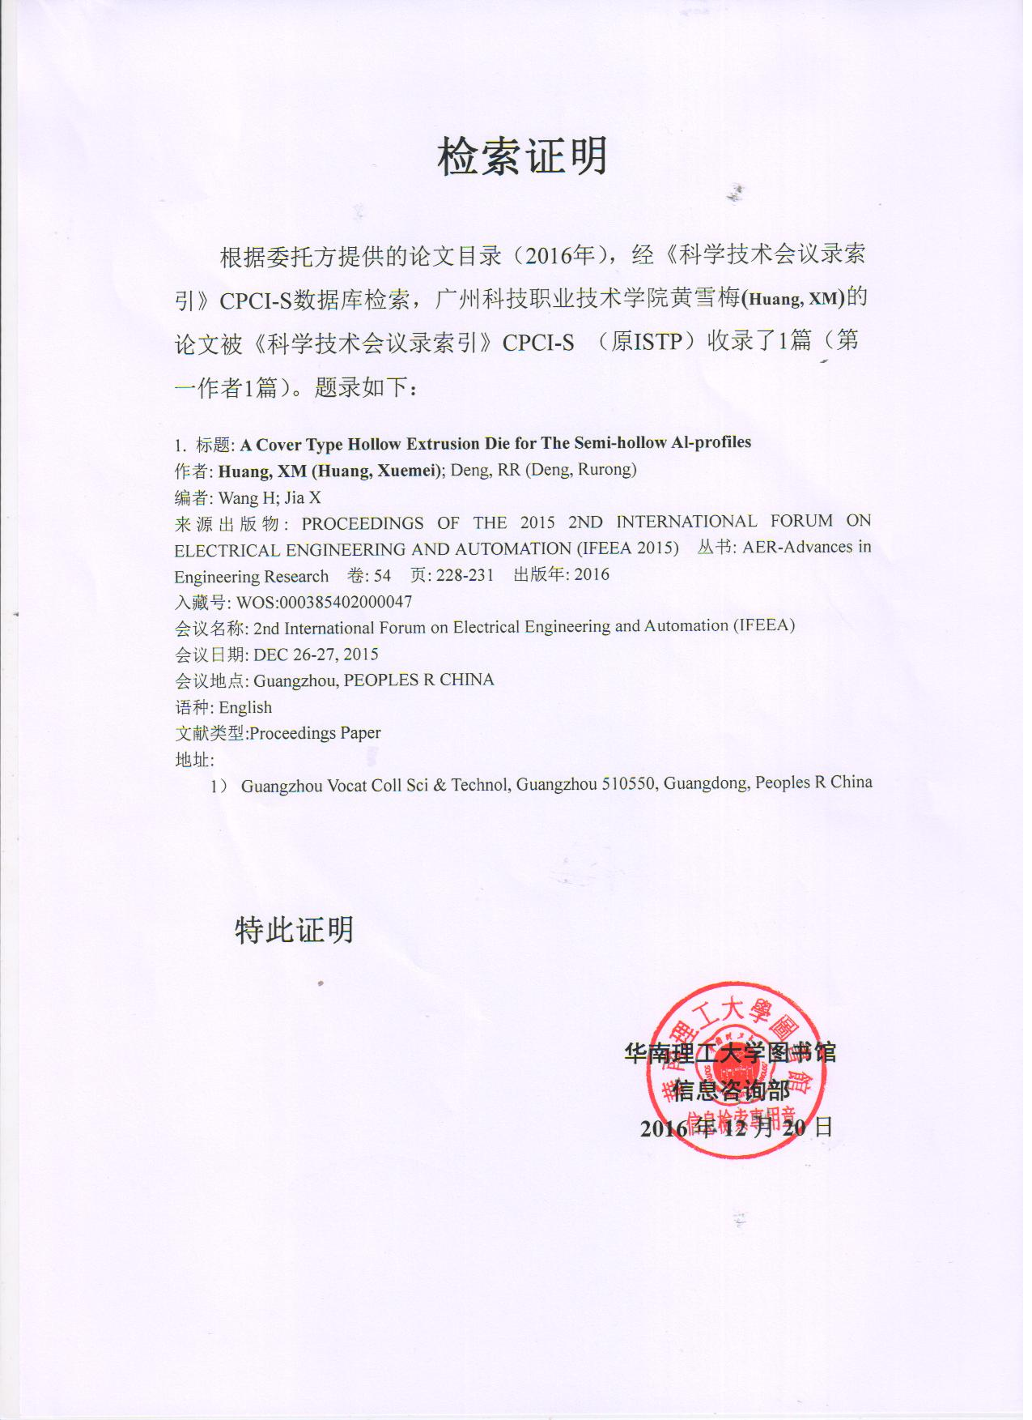

4、The Aluminum Extrusion Die With Twin Cavities For The Frame In Solar Plate
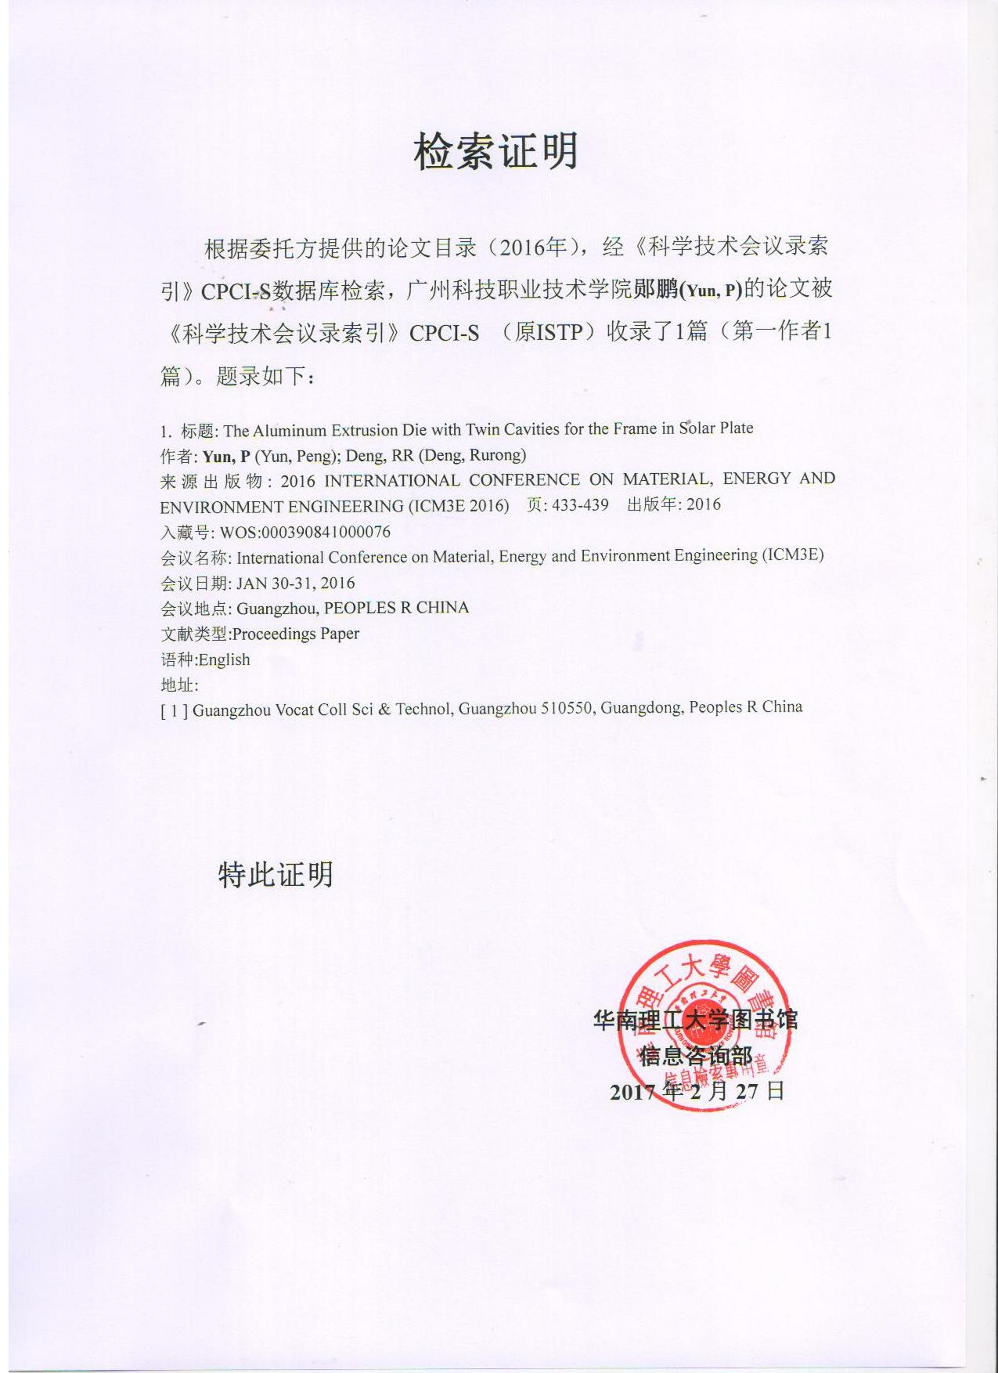

5、A Cutting Type Porthole Die Structure For Semi-hollow Al-Profiles
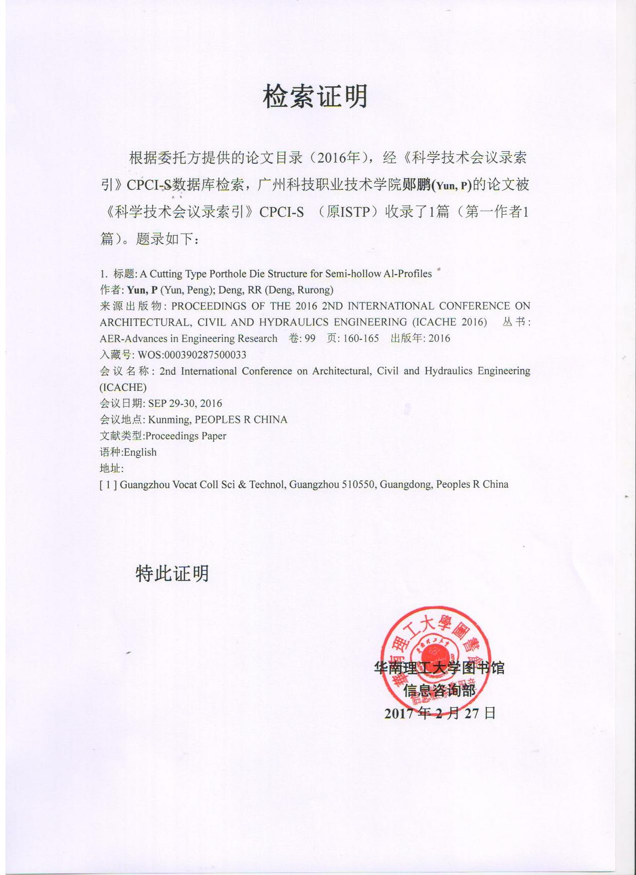

6、A Protection Type Porthole Die With Twin Cavities For semi-Hollow Al-Profiles
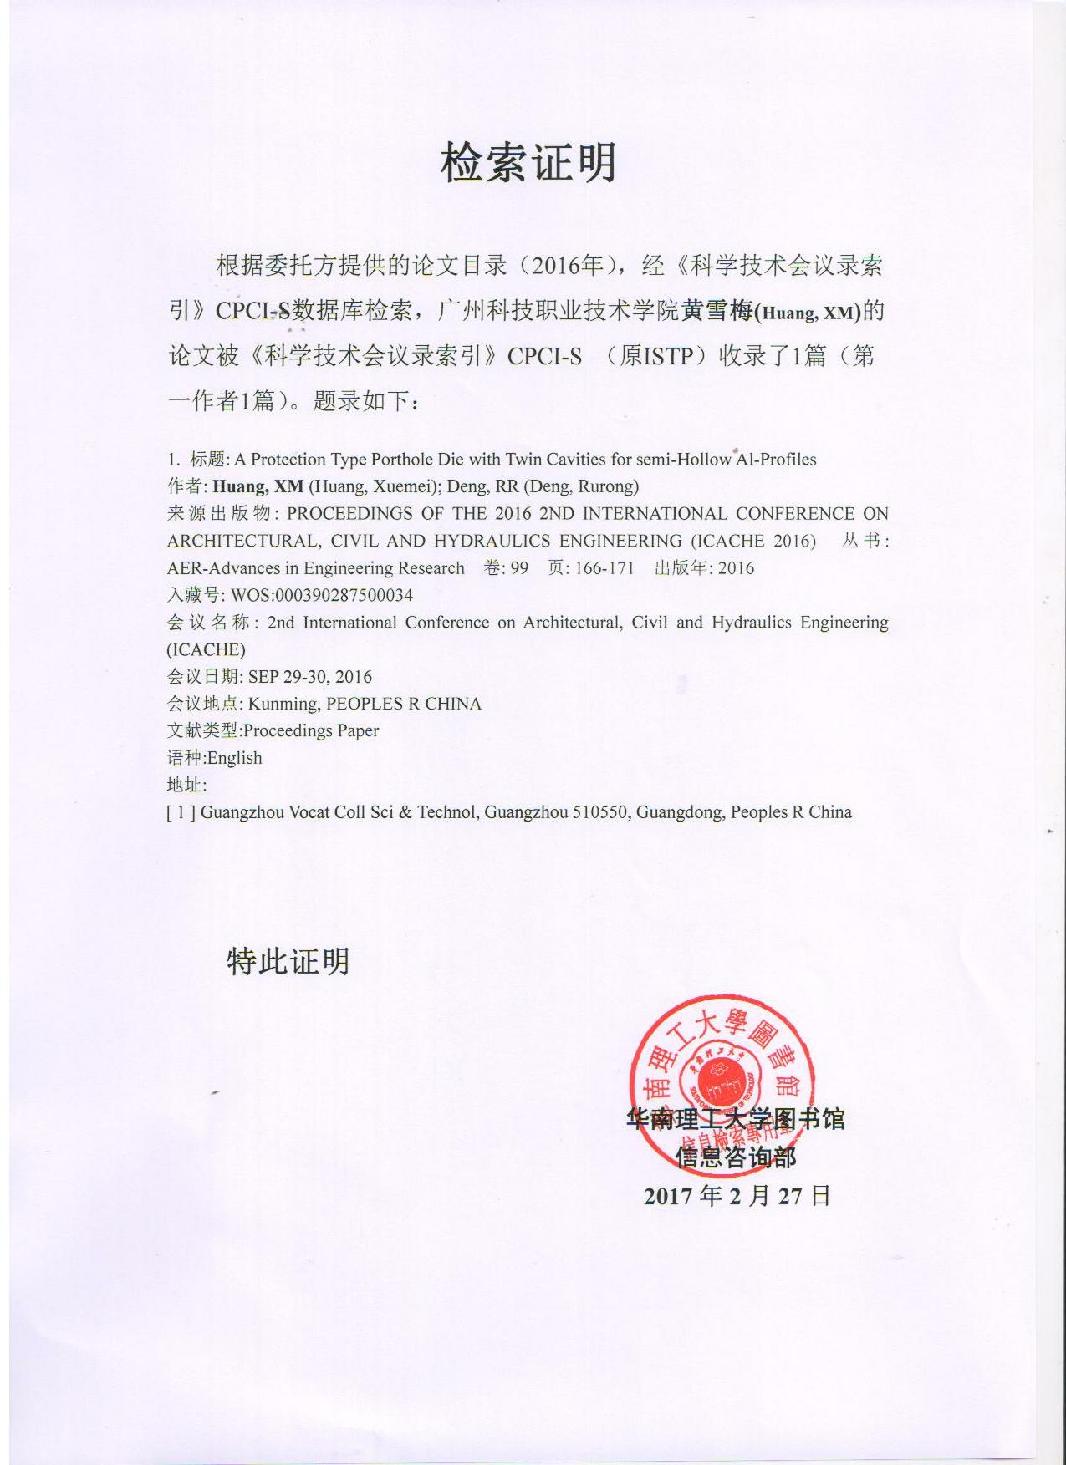

7、A Covering Type Extrusion Die With Twin Cavities For Semi-Hollow Al-Profiles
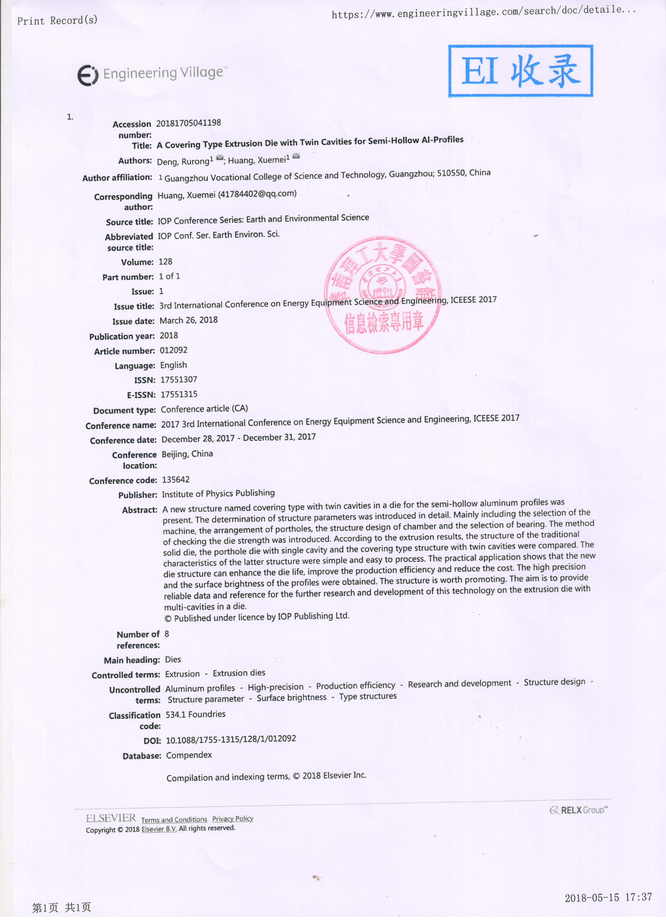

8、A aluminum alloy extrusion die structure on the large flat tube
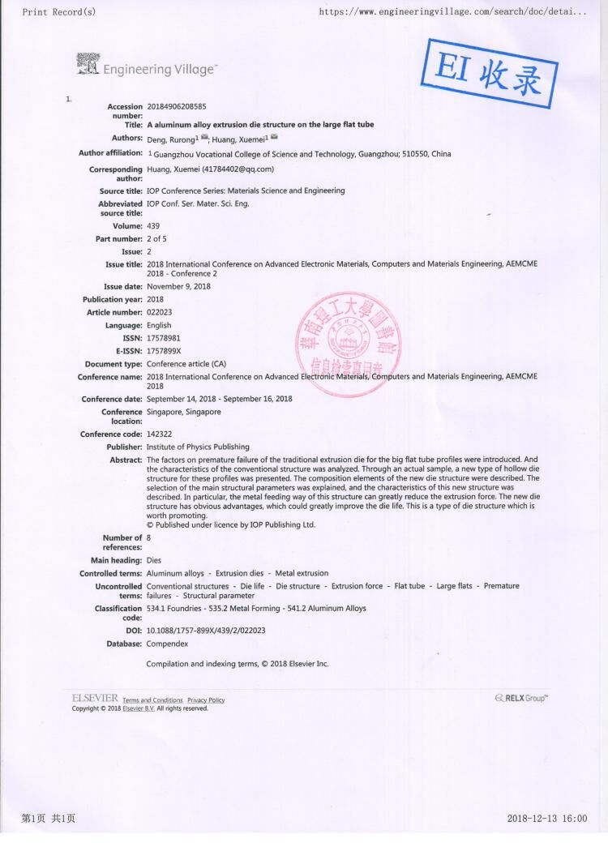

9、Study on Die Structure for Reducing Extrusion Force of Porthole Die
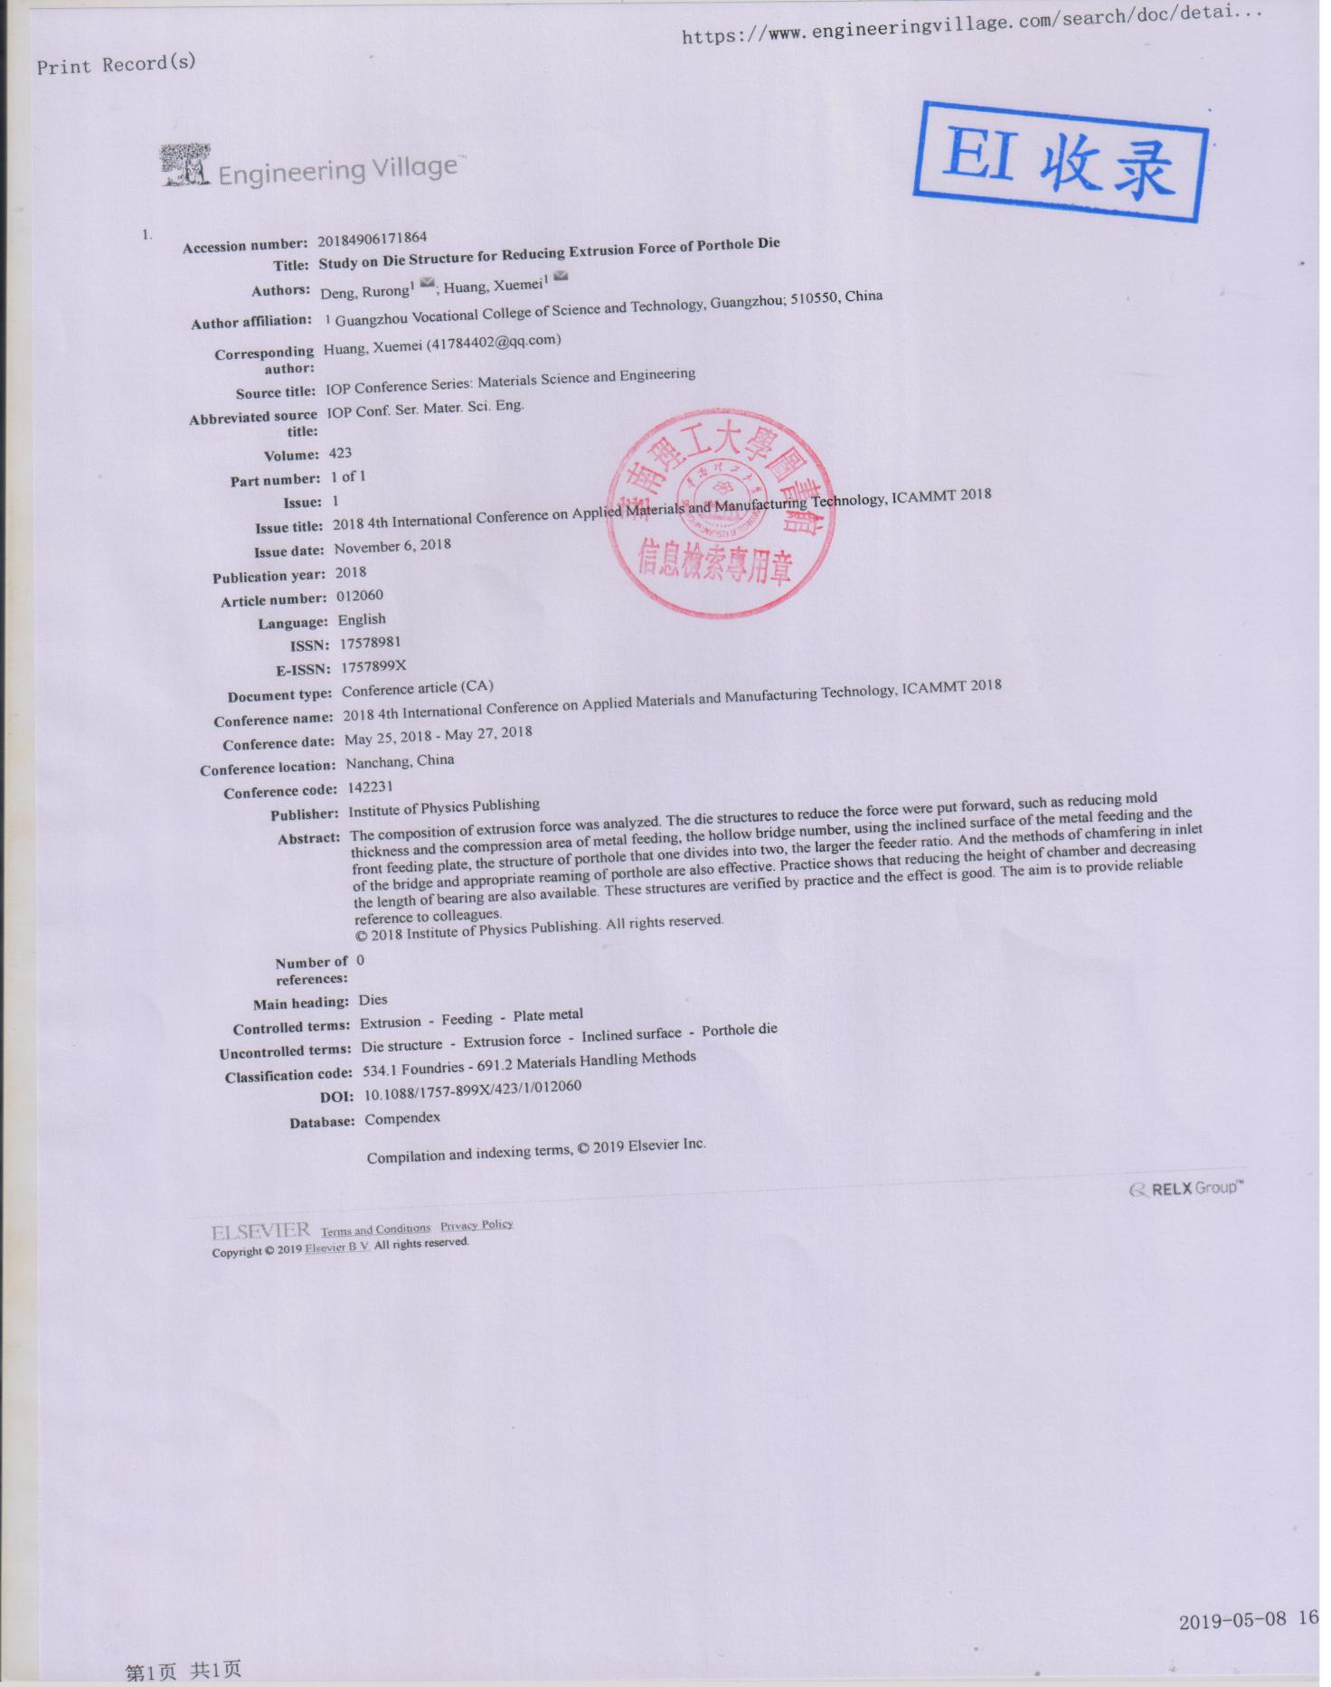

An Extrusion die for parallel collection Al flat tube of automobile heat exchanger
